

**ESSAY SUBMISSION COVERSHEET**

|  |  |
| --- | --- |
| **MODULE CODE AND TITLE** | PO687: Political Research and Analysis |
| **SEMINAR LEADER** | Guillermo Reyes Pascual |
| **FORENAME** | Wilmot |
| **SURNAME** | Emily |
| **LOG-IN** | Ew410 |
| **DO YOU HAVE AN ILP?** | Yes |
| **WORD COUNT** |  |
| **NB.**This form will add 95 words to your word count. Please subtract this from your total when entering your word count in the table above. | |

The Word Count Policy and guidance on style and referencing can be found in the Pol/IR Student Guide, available on Moodle <https://moodle.kent.ac.uk/2020/course/view.php?id=434>.

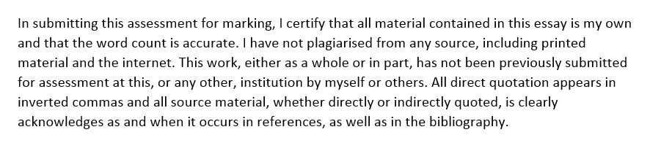The University Academic Discipline Regulations are contained in Annex 10 to the Credit Framework: <https://www.kent.ac.uk/teaching/qa/credit-framework/creditinfoannex10.html>.

**Please type or insert your assessment below the line**

PREDICTOR = LITERACY RATES = INTERVAL

OUTCOME = MEDIAN AGE = RATIO

QUESTION 1

For this assignment, I chose to use the ‘world’ data set. Following a close examination of the data set and accompanying codebook, I decided to inspect the relationship between a country’s median age and its literacy rates. More specifically, I want to see if literacy rates is a good predictor of a country’s median age. The predictor variable is literacy rates, and this is measured continuously. (is this right?) The outcome variable is median age, which is also measured continuously. (is this right?) Any possible correlation will be considered significant if it has a p value of <0.05.

H1: Countries with a lower literacy rate tend to have a lower median age.

H0: There is no relationship between literacy rates and the median age in a country.

QUESTION 2

The predictor variable, literacy, is a country’s literacy rate. This is an interval variable. The measurements of central tendency are as follows; the mean of the variable is … And the median is …. The minimum variables are … and the maximum are …. The standard deviation is ….

The outcome variable, *pop age,* is a country’s median age in years. The level of measurement of this variable is ratio. The measurements of central tendency are as follows; the mean of the variable is … And the median is …. The minimum variables are … and the maximum are …. The standard deviation is ….